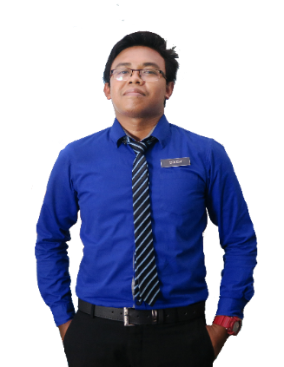

* Excellent written and verbal communication skills.
* Strong problem-solving and analytical skills.
* Ability to work independently in a fast-paced environment.
* Strong interpersonal skills and positive work ethic.
* Able to coordinate several tasks simultaneously.

**STRENGTH**

**ACHIEVEMENT**

* Secretary of Sports Club
* Committee Members of Puteri Islam 2007
* Vice-Chairman of the Discipline Bureau
* Vice-Chairman of Pengakap Laut 2010 & 2011
* Khatam Quran Recitation 30 Juzuk
* The Best Arabic Language Students

**SEKOLAH MENENGAH KEB LAKSAMANA KOTA TINGGI**

+60132805916

resumecreative@yahoo.com

**CONTACT**

Lake View Apartment (BlockA 06-20), Jalan Austin Perdana 1, Taman Austin Perdana, 81100 Johor Bahru, Johor

Mar 2010 - Dec 2012

Mar 2015 - Jan 2019

2019 - Present

2005 - 2007

2008

2008 - 2011

**DS MOBILE COMMUNICATION (OPPO SIGNAGE)**

**INTEREST AND HOBBIES**

**SPORT**

**TRAVEL**

**MUSIC**

**MOVIES**

**EN WANDI**

Manager,

Jalan Tun Habab, Pekan Kota Tinggi,

81900 Kota Tinggi, Johor.

Phone: +6019-4760161

**MAYRES HOTEL KOTA TINGGI**

**WINK SALOON**

Dec 2012- Mar 2015

**MBO CINEMAS HERITAGE MALL KOTA TINGGI**

Shampoo Girl

Sales Executive

Receptions

Cashier

**EXPERIENCE**

**SEKOLAH KEB AGAMA BANDAR KOTA TINGGI**

Ujian Pencapaian Sekolah Rendah (UPSR)

Penamatan Darjah Khas

**ASRAMA SEKOLAH KEB GEMBUT**

Penilaian Menengah Rendah (PMR)

**RACE: MALAY**

**DATE OF BIRTH: 29 SEPTEMBER 1995**

**MARITAL STATUS: SINGLE**

**SITI MUTAHQIERIN**

**EDUCATION**

**SITI MUTAHQIERIN BINTI ROSLI**

I am a fast learner, self-motivated and able to work independently with minimum supervision. Efficiency to work under pressure with systematic manner. Willing to learn and able to cooperate in teamwork.

**REFERENCE**

**24 YEARS OLD**

**LEADERSHIP**

**PERSONAL SKILLS**

**TEAMWORK**

**COMMUNICATION**

**ENGLISH**

**LANGUAGE**

**MALAY**

**COMPUTER**

**MICROSOFT EXCEL**

**MICROSOFT WORD**

**MICROSOFT POWERPOINT**

**PROFESSIONAL SKILLS**